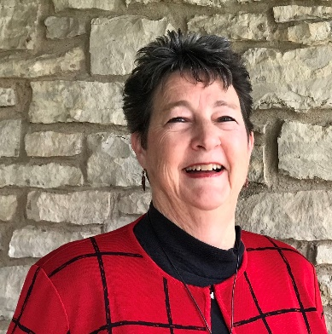
Rev. Soozi Whitten Ford
Interim Associate General Secretary
for Regional Ministries
American Baptist Churches USA

Rev. Soozi Whitten Ford serves as the Interim Associate General Secretary for Regional Ministries in the Office of the General Secretary ABCUSA; and as the (volunteer) Special Assistant to the Executive Director of International Ministries, Rev. Sharon Koh, in the role of Chaplain.

In 2021, Ford retired from the American Baptist Churches of Indiana and Kentucky, where she served as Executive Minister for more than nine years. She is a graduate of Ottawa University and Central Baptist Theological Seminary, and was ordained by Prairie Baptist Church (Prairie Village KS). Ford’s previous ministry experiences include faculty positions with Sterling College (Sterling KS) and Central Baptist Theological Seminary (Shawnee KS); pastoral positions with First Baptist Church (Casper WY) and Calvary Baptist Church (Cheyenne WY); regional ministry with Mid-American Baptist Churches (Iowa and Minnesota); and national stewardship ministry with American Baptist Churches USA. International mission experiences have included the opportunity to preach and teach, and work alongside local leaders, in Nicaragua, Honduras, Mexico, the Dominican Republic, Northeast India, and South Africa.

Throughout her ministry journey, Ford has served on numerous teams, task forces, and boards – at local and national levels. She recently completed terms with the Nehemiah Leadership Network and served as Vice Chair of the board for Green Lake Conference Center (Green Lake, WI); and on the American Baptist Women in Ministry Advisory Team. Along with Dr. Tom Wiles, she will co-chair the 2022 conference, Radical. Redeemed. Ready: Celebrating Ministering Women.

Ford has shared her life with Rev. Homer Ford (pastor of First Baptist Church, Franklin IN) for forty years, and together they have two daughters and a son-in-law: Ashley Ford, and Holly and Michael Kelly. Unscheduled time is often filled with connecting with family and dear friends; reading suspense novels; chasing the genealogical clues left by elusive ancestors; coaxing flowers to grow instead of weeds; knitting and planning the next travel adventure.

soozi.ford@abc-usa.org
484-686-4862 (mobile)

