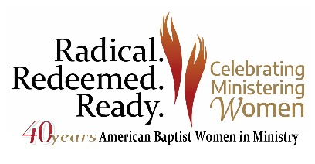

Radical. Redeemed. Ready.
Travel Grant Application

Travel grants are available to help offset the cost of travel and participation in the “Radical. Redeemed. Ready.” conference, to be held June 15-18, 2022, at the Green Lake Conference Center in Green Lake, Wisconsin. These scholarships are given based on expressed need and will be offered on a limited basis.

Special consideration will be given to conference attendees who are:
- traveling to the conference from Puerto Rico;
- members of the Burma Diaspora;
- age 35 and under.

Tab through the document to fill in all the fields below.
- Applicant Information
Full Name:
Mailing Address:
Email:
Mobile Phone:
Name of Region:
Church Membership (Name, City, and State):

- Please indicate the scholarship amount you are seeking ($100-$500):

- How would attending Radical. Redeemed. Ready. impact your discipleship journey?

- If you fall into any of the above special consideration categories, please note here:

- Is there any additional information you would like to share?

By submitting this application, I certify that all the information submitted with this application is true and correct.

Application submitted by (name of person): (your name typed here is your electronic signature)
Date:

Please note:
- Incomplete applications will not be considered.
- Application deadline April 15, 2022.
- Completed applications should be sent via email to grants@abc-usa.org

