Burma Advocacy Group
Convened by the American Baptist Churches
March 1, 2022
Dear Pastor/ Leader:
I write to you to ask your church to participate in a signature campaign promoted by the Burma Advocacy Group, a coalition convened by the American Baptist Churches Commission on Burma Refugees. The Burma Advocacy Group (BAG) is a group of leaders from associations, churches, community groups and acting with one voice to advocate for the passage of the Burma Bill. Representatives from the following organizations are participating:
-American Baptist Churches USA, -International Advocacy Baptist Collaborative, -ABC of Greater Indianapolis, -Kachin Alliance of USA,
-ABC of Nebraska, -Kachin American Baptist Association,
-Baptist World Alliance and 21 Wilberforce, -Kachin Baptist Churches USA,
-Burmese American Community Institute, -Karen Baptist Churches USA,
-Burmese Refugee Commission, -Karen Organization of America,
-Chin Association of Maryland, -Karenni Baptist Churches USA,
-Chin Baptist Association North America, -Mizo Society of America,
-Chin Baptist Churches USA, -Myanmar Baptist Churches USA,
-Chin Community of Indiana, -U.S. Campaign for Burma,
-Grassroots Movement for Burma, -U.S. Chin Coalition.
We would like to give a special thanks to our friends at www.21Wilberforce.org for partnering with us as
we defend freedom and justice in Burma.

The Goal of the Campaign is to gather and submit as many signatures as possible to our US Senators and Representatives to request them to pass the (revised) Burma Bill that is under consideration. The Burma Advocacy Group believes the Burma Bill is our greatest opportunity to achieve:
- an end to the human tragedy and crimes against humanity in Burma,
- an end the brutal military dictatorship in Burma, and
- an opportunity to achieve a federal democracy in Burma for which the people of Burma have been giving their lives.

Please promote the Signature Campaign in your congregation as well as with other churches and community groups who might participate to help pass the Burma Bill. We ask you 1) to share the campaign information in this letter and attached petition with your congregation and others via your website or other means. 2) We suggest you ask your youth group to assist any who need help to sign with the QR code by walking them through the QR process. Hard copies of the petition, which is attached, may be printed for people to sign. Signed hard copies must be photographed and emailed to Burmaadvocacygroup@gmail.org. This is another task your youth group might do.

The announcement on the next page has been included for you to share in your Sunday bulletin along with the petition. The deadline for gathering signatures is March 31, 2022.

In Christ,
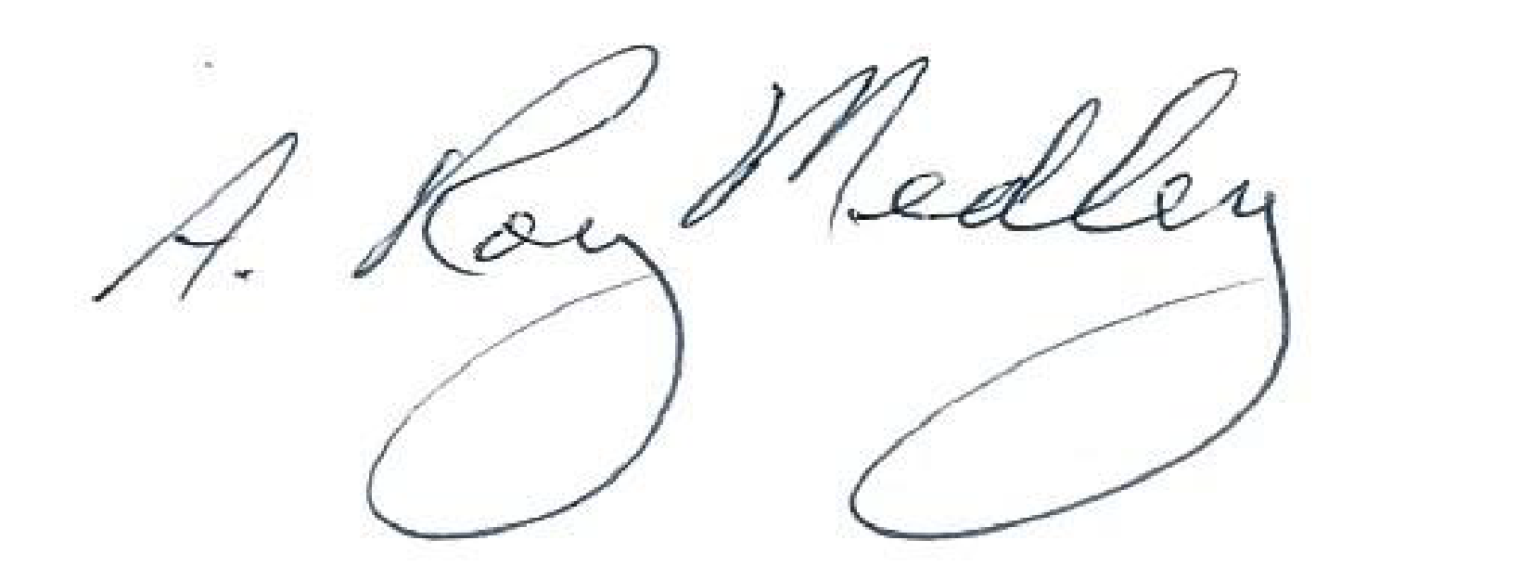
Rev. Dr. A. Roy Medley, Convener
General Secretary Emeritus, American Baptist Churches

Pray and Act for Burma

Here Are 4 Different Ways you can join the signature campaign to help the people of Burma. Your signed petition will be sent to your U.S. Senators and Representative. Your information will be fully protected and will not be shared with anyone other than your United States Senators and Representatives.

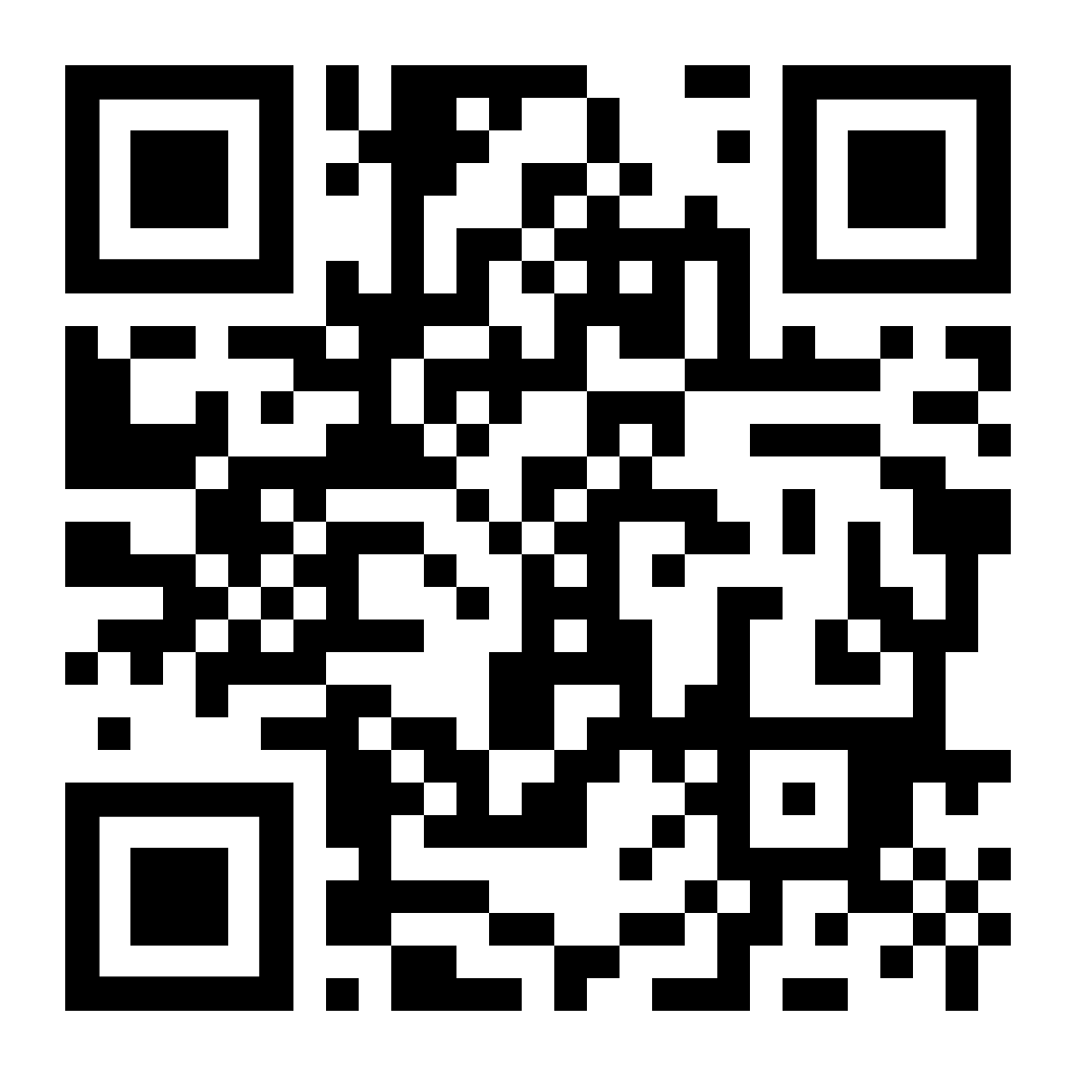
- Point your phone camera at the QR code below which will take you to the web site to sign up and submit the petition, or

- Go to www.Burmaadvocacygroup.org and follow the instructions to sign up and submit the petition, or
- Facebook: Burma Advocacy Group. Use the QR code to sign up and submit the petition, or
- If you are not comfortable with option 1, 2, or 3 above, please request a copy of the petition available from your church or community organization. They will photograph it once you have signed it and will email it to the Burma Advocacy Group on your behalf.

Please sign up only once, and only U.S. citizens 18 years and older.

Burma Advocacy Group
Burma Bill Petition Campaign

As a concerned citizen of the United States, I am asking you, my senators and my representative, to support and co-sponsor the Burma Bill in an amended form that:
- Supports a new constitution that provides for the establishment of Federal Democracy in Burma.
- Recognizes the National Unity Government (NUG) as the official democratic government of Burma and rejects the State Administration Council (SAC).
- Authorizes emergency Covid aid for Burma including vaccines and therapeutics. Thousands have died from Covid including hundreds of monks and pastors.
- Provides direct, cross-border emergency humanitarian aid, which bypasses the Burma Military Regime aid, to the thousands of Internally Displaced Persons (IDP) and individuals in the Civil Disobedience Movement (CDM) in need.
- Engages with India, Thailand, and Malaysia both to assist with aid programs for refugees from Burma and to secure their safety.
- Continues to engage with other countries to enforce targeted sanctions against the military junta and its economic interests and to cease supplying arms to the military junta.
- Supports Religious freedom and human rights for ALL in Burma.
- Does not advocate for the current Nationwide Ceasefire Agreement, which has been rejected by many ethnic groups as a basis for peace, but supports a new peace agreement policy and process.

_____ (Please initial) I am a citizen of the United States, and 18 years or older.

Full Name: _____________________________ _______
Address:_______________________________________________
City State Zip Code ________
Email: _______________________________________________+
Phone # _______________________________________________
Signature: __________________ _Date:________________

