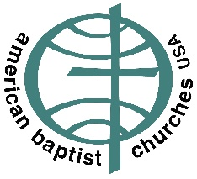
AMERICAN BAPTIST CHURCHES USA
___________________________________

Rev. Dr. C. Jeff Woods
General Secretary

February 2, 2022

Dear Pastor,

February 1st, marked the one-year anniversary of the military overthrow of the democratic elections in Burma. This was quickly followed by arrests of opposition leaders both at the national and the state level. Since the coup, countless youth and others have been killed and arrested for their brave participation in the Civil Disobedience Movement (CDM). Villages and churches have been attacked and burned. Countless thousands have fled outside Burma or live as internally displaced persons (IDPs) within its borders.

On Sunday, February 6th Baptists unite to Pray and Act for Burma. I ask you as a pastor to lead your congregation on February 6th in a time of prayer for Burma. Imagine the power of all our conventions expressing solidarity in prayer for the realization of peace and justice in a federal democratic Burma!

We have provided a guide to prayer with suggested concerns to be lifted to our Lord in intercession. There is also a sample prayer enclosed that may be used in the service or at the communion table as we gather to remember Christ’s sacrificial love and to offer prayer for our brothers and sisters in Burma.

We also include a list of ways in which your congregation can continue to Pray and Act for Burma that she might know the blessings of peace, liberty and justice.

By the middle of February, you will receive a request for your church members to sign-on to a letter to the US Congress advocating for the Burma Bill and needed provisions within it. I hope you will encourage the congregation to sign on to this letter. Ideally, every church will host a signing after worship and other church activities through the end of February. A united voice from the diaspora community and supporters in the US will mean much for the successful passage of a bill that reflects the hopes and will of the people of Burma for a federal democracy in which all participate.

“Blow the trumpet in Zion; sanctify a fast; call a solemn assembly; gather the people.”
Joel 2:15-16a

Trusting in our Lord Jesus, let us continue to work and pray for Burma.

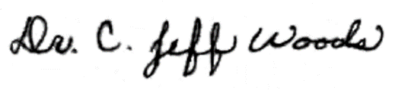
Sincerely

Dr. C. Jeff Woods
General Secretary

