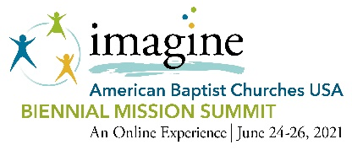
2021 Biennial Mission Summit
Scholarship Application

Scholarships are available to help offset the cost of registration for the 2021 Biennial Mission Summit – An Online Experience. These scholarships are given based on expressed need and will be offered on a limited basis. The scholarship may only be used for a Participant registration. If you have been selected to represent your church as a voting Delegate, you will not be able to use this scholarship toward that registration. Only one application per family will be considered.

Tab through the document to fill in all the fields below.
- Applicant Information
Full Name:
Mailing Address:
Email:
Mobile Phone:
Name of Region:
Church Membership (Name, City, and State):

Please indicate your current employment status:
Employed – Full Time
Employed – Part Time
Unemployed/Furloughed
Retired
Student
Other, please specify

Please indicate the scholarship amount you are seeking:
$50.00
$75.00

Have you attended an on-site Biennial Mission Summit in the past?
Yes, in (please indicate year or location)
No, this would be my first event.

Is there any additional information you would like to share?

By submitting this application, I certify that all the information submitted with this application is true and correct.

Application submitted by (name of person): (your name typed here is your electronic signature)
Date:

Please note:
- Incomplete applications will not be considered.
- Application deadline May 30.
- Completed applications should be sent via email to MissionSummitProgram@abc-usa.org.
- Scholarships are awarded by a Discount Code that will be used during the registration process. Discount Code cannot be converted to cash.
- Discount Code provided can only be used once.

