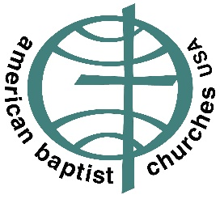
ABCUSA Call to Prayer for Myanmar 2021

American Baptist Churches USA Mission and History

ABCUSA is one of the most diverse Christian organizations with approximately 5,000 local congregations comprised of 1.3 million members throughout the United States and Puerto Rico. Its history of involvement with Burma (Myanmar today) dates back 200 years, when Ann and Adoniram Judson, the first American missionaries landed in the port of Rangoon on July 13, 1813. The Judsons and other early missionaries introduced Christianity to the Burmese, Chin, Karen, Kachin, Shan and many other ethnic groups of Burma. As a result of the American Baptist mission work, Baptists constitute the largest Christian organization in Myanmar, currently numbering nearly 1.4 million members in 17 Baptist Conventions. The Myanmar Baptist Convention (MBC) based in Rangoon is the umbrella organization with oversight to the Conventions.
Christians in Myanmar have produced the largest number of religious workers among their own people. International Ministries (IM), ABCUSA’s global ministries organization, continues its support to MBC and related Baptist churches through relief and development, educational scholarships, theological training, church development, and medical work in the country. American Baptists Home Mission Societies (ABHMS), the domestic ministries organization of ABCUSA, has sponsored nearly 120,000 world refugees with its partner organization, Church World Service (CWS), since after World War II through its office of immigration and refugees.
In the spring of 2007, the national Burma Refugees Task Force (BRTF) was initiated in response to the influx of Burma refugees. The name was changed to the Burma Refugee Commission (BRC) in 2014. There are 80,000 Burma refugee immigrants who are now affiliated with ABCUSA and live across 130 cities and towns, urban and suburban areas. These Burma “diaspora” communities and churches are working closely with ABCUSA and with their respective conventions to advocate for the concerns of those in Myanmar suffering from human rights and religious freedom violations. They also raise funds to assist their vulnerable families and ethnic communities in Myanmar, in refugee camps in Thailand, and displaced people in Malaysia and India.

