December9, 2013

Member of Congress

US Senate/House

Washington, DC

Dear Member of Congress,

On Martin Luther King Day, January 17, 2011, 24 national faith groups announced the formation of “Faiths United to Prevent Gun Violence,” a diverse coalition of denominations and faith-based organizations united by the call of our faiths to confront America’s gun violence epidemic and to rally support for policies that reduce death and injury from gunfire. Nearly three years later, we have grown to over 50 groups representing over 80 million Americans in faith communities across the nation – and our call to confront this epidemic has grown ever more urgent and imperative.

With heavy hearts, we now approach the one-year anniversary of the Sandy Hook Elementary School shooting on December 14, 2012. On that tragic day, our nation saw the loss of 20 defenseless young children and of six of the teachers and administrators that cared for them. We continue to mourn that unnecessary loss of life, and the dozens of lives lost to gun violence each and every day since then. Faith leaders in Newtown have been on the front line of responding to the unimaginable grief and pain of the families, and of the entire community there. Across the country, we grieve with our own congregants and communities, and we share the determination of them all to do all within our power to ensure that we stop this constant onslaught of violence.

In light of the tragedy in Newtown – and in Aurora, Tucson, Fort Hood, Virginia Tech, Columbine, Oak Creek, Sparks, and so many more communities day after day – we know that no more time can be wasted. Gun violence is taking an unacceptable toll on our society. While we continue to pray for the families and friends of those who died and share in their grief, we must also support our prayers with action. We have a moral obligation to keep guns out of the hands of people who may harm themselves or others.

Each of us has a role to play in reducing gun violence in our communities. Congress must take action to do its part. Faiths United to Prevent Gun Violence reiterates our support of immediate legislative action to pass the **[Manchin-Toomey bill (Amendment to S. 649)/King-Thompson bill (H.R.1565)]** to expand gun background checks to gun shows, internet sales, and commercial sales. These proposals are widely supported by the public. And research demonstrates that in the 16 states and Washington, D.C that already require background checks for private sales, gun trafficking is 48 percent lower, the rate at which women are killed with a gun by an intimate partner is 38 percent lower, and the gun suicide rate is 49 percent lower.  Congress must act to ensure that background checks are required to protect innocent lives nationwide.

***For those Senators who supported before:***

**We sincerely thank you for your support of the Manchin-Toomey amendment last April, and prayerfully urge you to do all that is needed to ensure the proposal’s immediate reconsideration and passage.**

***For those Senators who opposed before:***

**We strongly and prayerfully urge you to reconsider your previous position in opposition to the Manchin-Toomey amendment, and to work with your colleagues to ensure this proposal’s immediate reconsideration and passage in the Senate.**

***For those House Members who have cosponsored:***

**We sincerely thank you for your cosponsorship of H.R. 1565, and prayerfully urge you to do all that is needed to ensure its immediate consideration and passage.**

***For those House Members who have not yet cosponsored:***

**We prayerfully urge you to cosponsor H.R. 1565, and to do all that is needed to ensure its immediate consideration and passage.**

Faiths United to Prevent Gun Violence member organizations, representing millions of people across the country, implore our federal elected leaders to respond to this crisis in our nation. With each day that goes by, dozens more of our children, parents, brothers, and sisters are lost to the violence of guns. Should you or your staff have questions or need additional information, please feel free to go to our website at [www.faithsagainstgunviolence.org](http://www.faithsagainstgunviolence.org)or contact our National Coordinator, Vincent DeMarco, by email at [demarco@mdinitiative.org](mailto:demarco@mdinitiative.org) or by phone at 410-591-9162.

Sincerely,

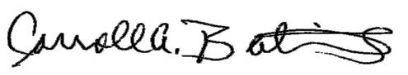

Dr. Carroll A. Baltimore, President

Progressive National Baptist Convention

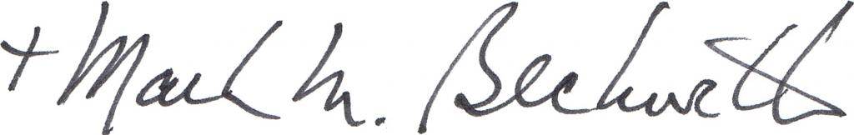

The Rt. Rev. Mark M. Beckwith, Chair

Episcopal Bishops Against Gun Violence



Peg Birk, Transitional General Secretary

National Council of Churches

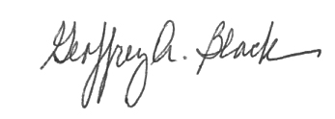

Rev. Geoffrey Black, General Minister and President

United Church of Christ



Carol Blythe, President

Alliance of Baptists

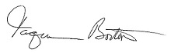

Taquiena Boston, Director of Multicultural Growth and Witness

Unitarian Universalist Association



Sister Simone Campbell, SSS, Executive Director

NETWORK, A National Catholic Social Justice Lobby

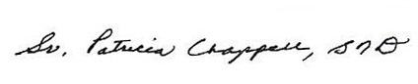

Sister Patricia Chappell, Executive Director

Pax Christi USA

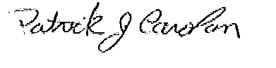

Patrick Carolan, Executive Director

Franciscan Action Network

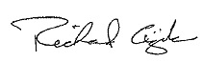

Rev. Richard Cizik, President

New Evangelical Partnership For the Common Good

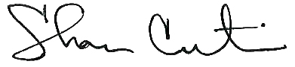

Shan Cretin, General Secretary

American Friends Service Committee

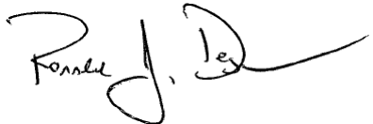

Rev. Ronald J. Degges, President

Disciples Home Mission, Christian Church (Disciples of Christ)



Jacquelyn Dupont-Walker, Director, Social Action Commission

African Methodist Episcopal Church

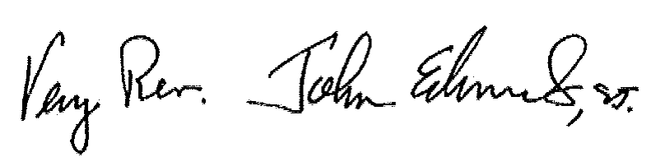

Very Rev. John Edmunds ST, President

Conference of Major Superiors of Men

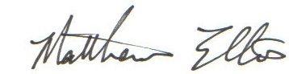

Matthew Ellis, Executive Director

National Episcopal Health Ministries

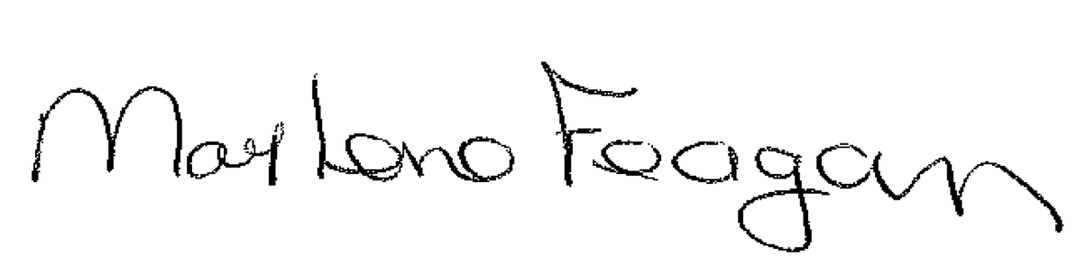

Marlene Feagan, President

Health Ministries Association

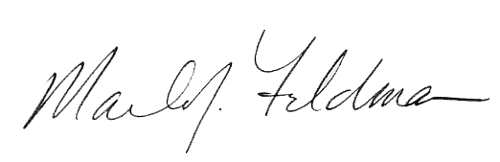

Rabbi Marla J. Feldman, Executive Director

Women of Reform Judaism

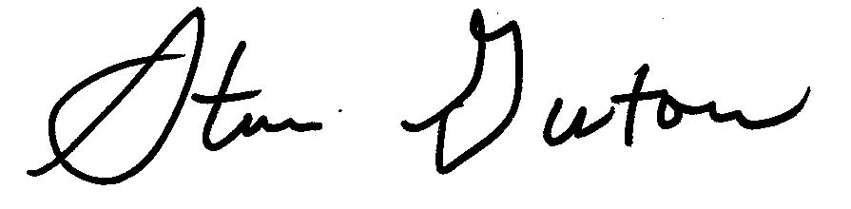

Rabbi Steve Gutow, President and CEO

Jewish Council For Public Affairs

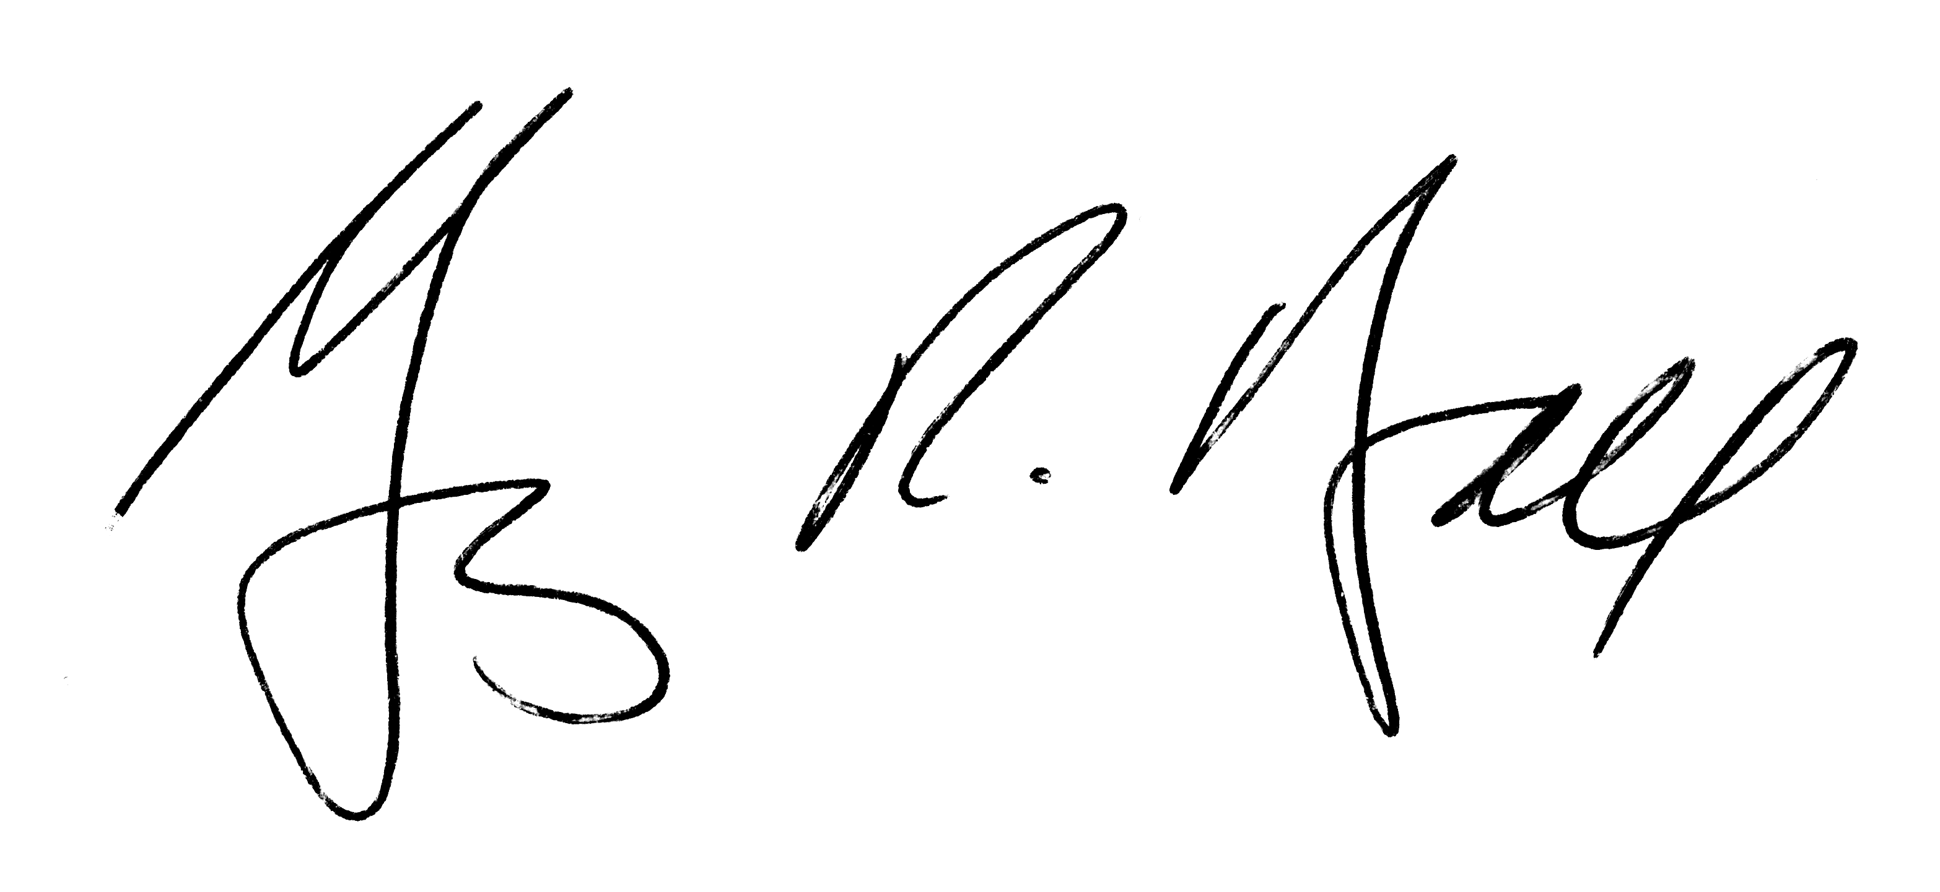

The Very Rev. Gary Hall, Dean

Washington National Cathedral

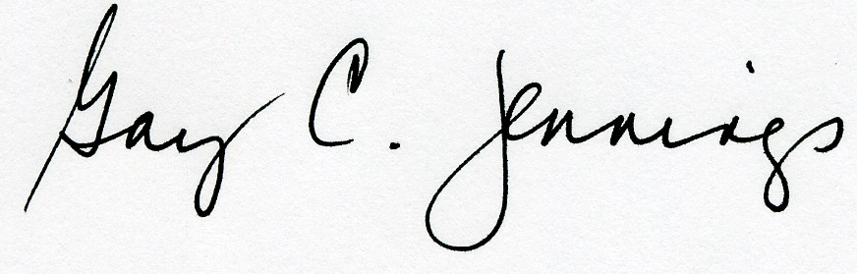

The Rev. Gay Clark Jennings, President, House of Deputies

The Episcopal Church

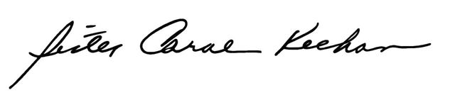

Sister Carol Keehan, D.C., President and CEO

Catholic Health Association

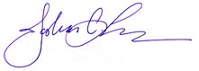

Rabbi Joshua Lesser, Tikkun Olam Commission Chairperson

Jewish Reconstruction Communities/RRC



Kevin E. Lofton, President and CEO

Catholic Health Initiatives

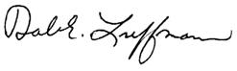

Reverend Dr. Dale E. Luffman, Ecumenical and Interfaith Officer   
Community of Christ

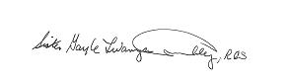

Sister Gayle Lwanga, RGS, National Coordinator

National Advocacy Center of the Sisters of the Good Shepherd

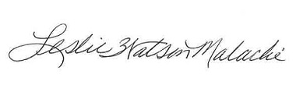

Rev. Leslie Watson Malachi, Director

African American Ministers in Action

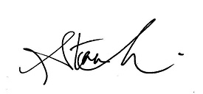

Stacy Martin, Director for Advocacy

ELCA, DC Office

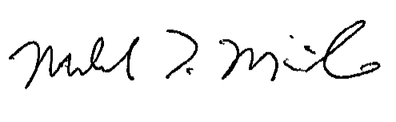

Pastor Michael McBride, M.Div.

PICO Network Lifelines To Healing



Sister Patricia McDermott, RSM, President

Sisters of Mercy of the Americas

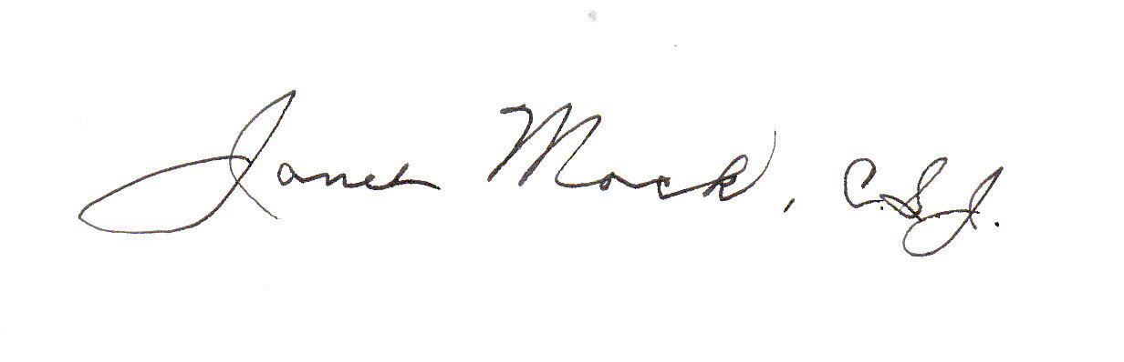

Sister Janet Mock, CSJ, Executive Director

Leadership Conference of Women Religious

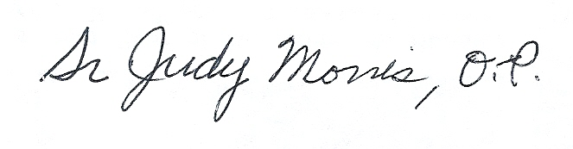

Sister Judy Morris, OP, Promoter of Justice

Dominican Sisters of Peace



Rev. Dr. J. Herbert Nelson, Director

Presbyterian Church (U.S.A) Office of Public Witness

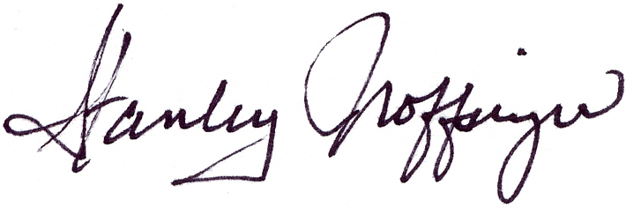

Stanley J. Noffsinger, General Secretary

Church of the Brethren



Dr. Walter L. Parrish II, Executive Minister

American Baptist Churches of the South

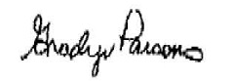

Rev. Gradye Parsons, Stated Clerk of the General Assembly

Presbyterian Church (USA)

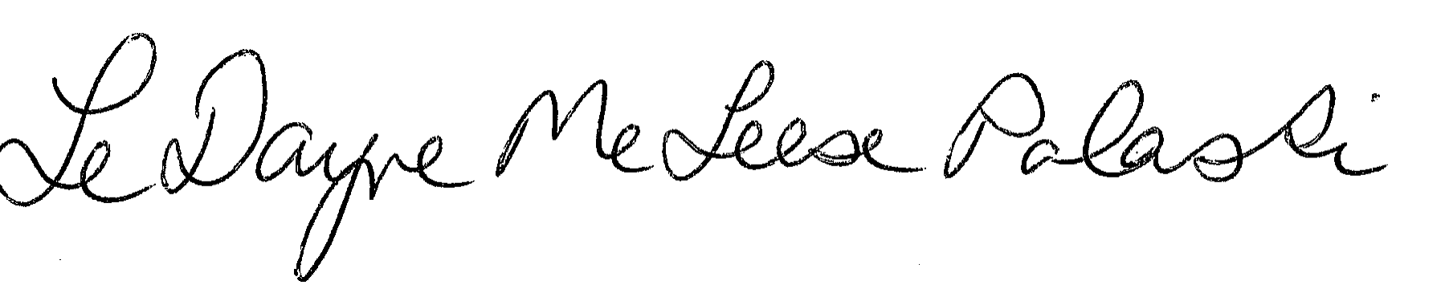

Rev. LeDayne McLeese Polaski, Program Coordinator

Baptist Peace Fellowship of North America



Diane Randall, Executive Secretary

Friends Committee on National Legislation



Fred Rotondaro, Chairman of the Board

Catholics In Alliance For The Common Good



Rev. Gabriel Salguero, President

National Latino Evangelical Coalition

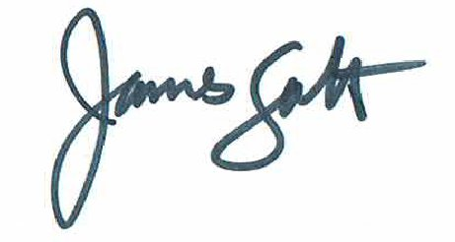

James Salt, Executive Director

Catholics United



Djamillah Samad, National Executive

Church Women United, Inc.

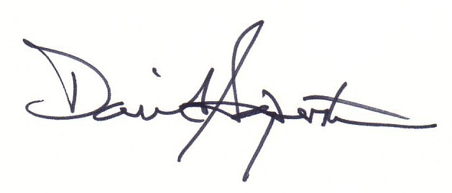

Rabbi David Saperstein, Director and Counsel

Religious Action Center of Reform Judaism

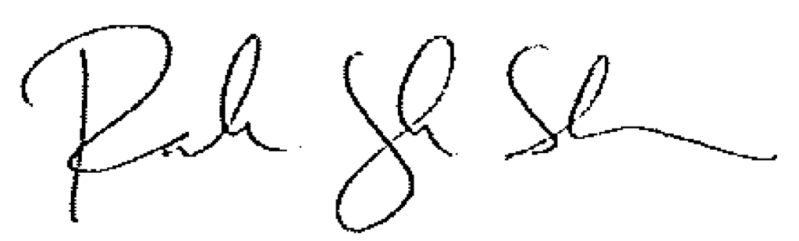

Rachelle Lyndaker Schlabach, Director

Mennonite Central Committee U.S. Washington Office

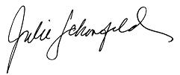



Rabbi Julie Schonfeld, Executive Vice President

Rabbinical Assembly

Suhag Shukla, Executive Director and Legal Counsel

Hindu American Foundation



Dr. Rajwant Singh, Chairman

Sikh Council on Religion and Education, USA



Father Larry Snyder, CEO

Catholic Charities USA



Dr. Sayyid Syeed, National Director For Interfaith and Community Alliances

Islamic Society of North America

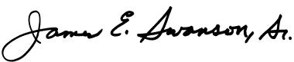

Bishop James E. Swanson, President

General Commission on United Methodist Men*  
(*Not a Member of the Coalition)

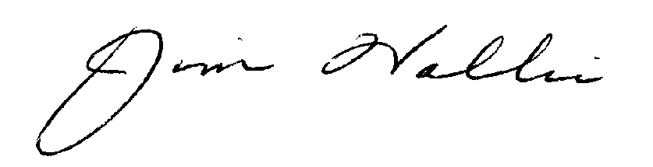

Jim Wallis, President

Sojourners

WenskiSignature

Most Reverend Thomas G. Wenski, Archbishop of Miami  
Chairman, Committee on Domestic Justice and Human Development

United States Conference of Catholic Bishops*  
(*Not a Member of the Coalition)



Rabbi Steven Wernick, Chief Executive Officer

United Synagogue of Conservative Judaism



James Winkler, General Secretary

General Board of Church and Society of the United Methodist Church

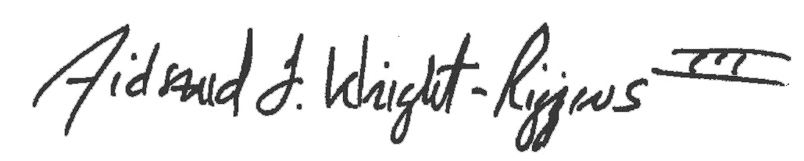

Dr. Aidsand F. Wright-Riggins III, Executive Director

American Baptist Home Mission Societies