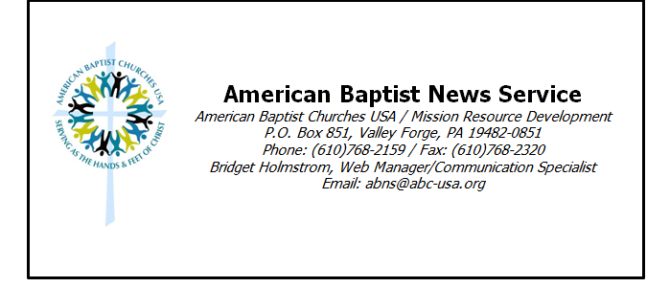

New Resources Available on Crucial Topics to Women
VALLEY FORGE, PA (ABNS 8/7/13)—American Baptist Women’s Ministries announces the release of two programmatic resources in a new series published by AB Women’s Ministries for women’s ministry, entitled In Their Shoes: Women Walking with Women Worldwide. The resources are In Their Shoes: Economic Empowerment and In Their Shoes: Immigrants and Refugees.
Each In Their Shoes book includes fact sheets, Bible studies, program sessions, activities for children, Scriptures for reflection, resource listings, and suggestions for ways to engage in the issue locally. The articles are written by women with personal expertise, experience, and passionate commitment to the topic.
Executive Director Virginia Holmstrom said, “The focus on Immigrants and Refugees and on Economic Empowerment addresses issues that deeply touch many women and their families in our neighborhoods and globally. Each resource is perfectly suited for use as a program resource for local church women’s ministries throughout the year, engaging persons in Bible study, education, and suggestions for mission outreach. The availability of the resources now is very timely as AB Women’s Ministries answers God’s call to empower women and girls to serve God. I’m hopeful that the resources will open hearts and minds and will help individuals and women’s ministry groups to be in mission together for the empowerment of women and girls everywhere.”
In Their Shoes: Economic Empowerment (W4933) and In Their Shoes: Immigrants and Refugees (W4932) are available for sale on the AB Women’s Ministries website store at www.abwministries.org/store and through Judson customer service; call 800-4-JUDSON.
The new In Their Shoes: Women Walking with Women Worldwide series of printed resources is part of a group of resources by AB Women’s Ministries that includes a podcast series and blog of the same name. The podcast is available at www.intheirshoespodcast.org or subscribe through iTunes; the blog is available at http://intheirshoesblog.wordpress.com. These multi-media resources invite participants into deeper understanding and engagement in critical issues having impact upon the welfare of women and girls globally.
American Baptist Women’s Ministries is a Christ-centered ministry with a commitment to encourage and empower women and girls to serve God. Additional American Baptist Women’s Ministries resources are available at www.abwministries.org.
American Baptist Churches is one of the most diverse Christian denominations today, with over 5,200 local congregations comprised of 1.3 million members, across the United States and Puerto Rico, all engaged in God’s mission around the world.

