ABCUSA MATTHEW 25 GRANT
APPLICATION

An anonymous donor has given a sum of money through American Baptist Churches USA to be used for programs that address “housing, feeding, education and health with regards to the less fortunate.” The donor’s primary concern is to help ameliorate poverty. ABCUSA will distribute grants of up to $5,000 semi-annually as long as this donor continues to make donations. Recipients will be selected largely based on the degree to which the funds will be used to directly assist those in poverty. Applicants must be in relationship with American Baptist Churches USA to be eligible to apply.

- General Information:
Organization Name_____________________________________________________________
Affiliation with ABCUSA_______________________________________________________
Address______________________________________________________________________
_____________________________________________________________________________
Phone_ _____________________________ Federal Tax ID#____________________________
Contact person____________________________email________________________________

- Please submit with your application a copy of:
- Your mission statement
- Your most recent annual report or audited financial statement

- How do you plan to use the requested funds? How will the funds specifically assist individuals battling poverty and its effects? (Please submit on separate sheet. Maximum of one page.)

- Total cost of the project________________________________________________________

- Amount being requested from the ABCUSA Matthew 25 Grant___________________________

- Your other funding source(s)____________________________________________________

I certify that all the information submitted with this application is true and correct, and that if a grant is awarded, we will use the funds for the purpose stated.

___________________________________________________ __________________________
Name/Title Date

Please note:
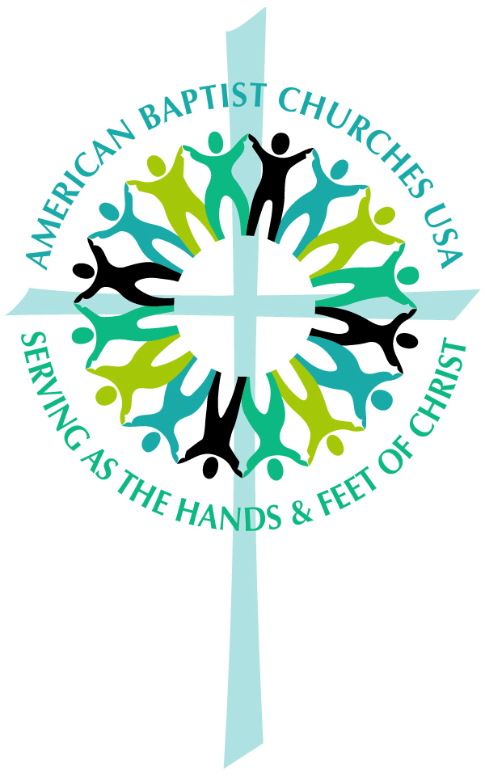
- Incomplete applications will not be considered.
- Application deadline is March 1 for grants distributed on April 15; Sept. 1 for grants distributed on Oct. 15
- Completed applications should be sent to:
Mission Resource Development
American Baptist Churches USA
P.O. Box 851
Valley Forge, PA 19482-0851

