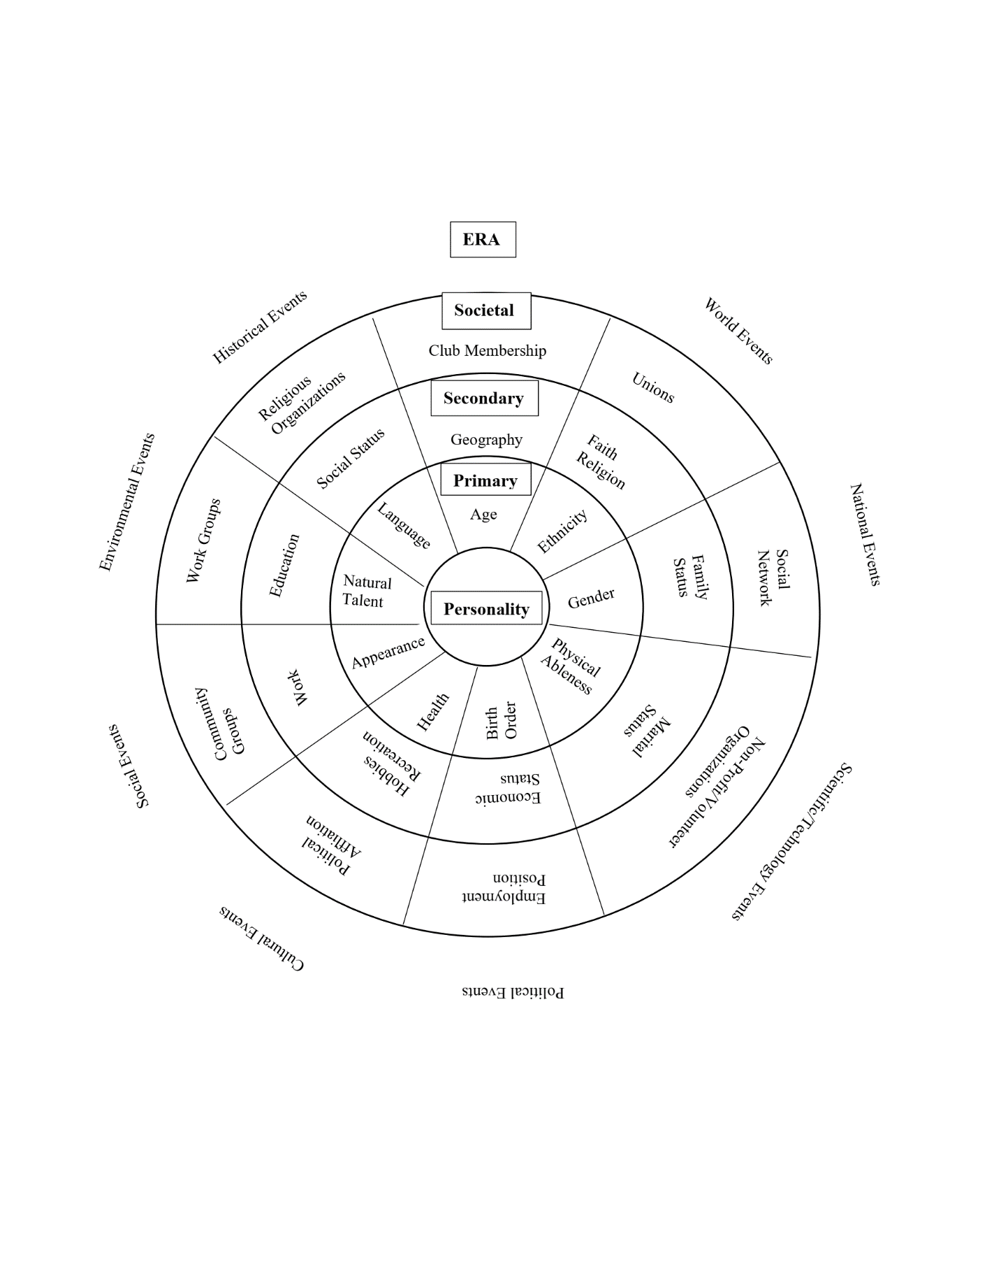**FIVE CIRCLES OF IDENTITY**

* Take a look and think about which 3 elements within the different circles, other than

personality and era, that have significantly influenced your life today.

* How you see things? How you act and behave? How you see others, especially those who are different from you culturally?
* Pick one of these influences, and share this with your table.
* Why and how has this influence affect how you see the world, and how you see others?
* Take no more than 2 minutes each. Be sure everyone has a chance to share.
* If you still have time, you can pick another influence to share.