

**Together, let’s thank our God—**

**and remember and thank our faithful pastors and missionaries.**

Dear Pastor,

This past year has been one of both recovery and enduring struggles for our American Baptist Churches community—a year that reminds us of all that pastors do for our churches, congregations, and the communities they serve.

**RMMO**2022 **theme: For all they’ve done**

As illustrated in this year’s campaign materials, our pastors are active. They pray, listen, baptize, marry, mourn, counsel, celebrate, and so much more. As a pastor yourself, you know the energy it takes to sustain our congregations through the ups and downs of life.

Please prepare your congregation for this year’s offering and preach to it on RMMO Sunday:

**December 4, 2022**

**RMMO**2022: For all they’ve done

“I thank my God every time I remember you.” (Philippians 1:3)

**This year’s highlight: Video and online tools**

Inside are the print materials you need to conduct **RMMO**2022 successfully, while our centerpiece video and other digital assets are available online at **abc-usa.org/RMMO**. Please refer to the promotional guide and calendar to begin preparing in November for RMMO Sunday on December 4.

**Why should congregations give?**

We give to remember and thank those who have dedicated their lives in service to Christ, the church, and us. With gift revenue from the RMMO 2021 offering, we distributed 3,395 thank you checks averaging $134, a modest amount in which the gesture says far more than the dollars. For all they’ve done, let’s do this for them again this year.

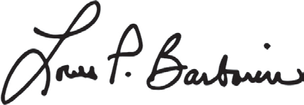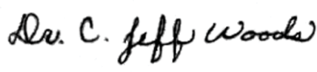Yours in Christ,

Dr. Louis P. Barbarin, CPA Dr. C. Jeff Woods

Chief Executive Officer Interim General Secretary MMBB Financial Services American Baptist Churches USA

**ABCUSA**

PO Box 851

Valley Forge, PA 19482-0851

**MMBB Financial Services** 475 Riverside Drive, Ste 1700 New York, NY 10115-0049

The Retired Ministers and Missionaries Offering (RMMO) is a congregational offering and a joint project of the ABCUSA and MMBB. Collected annually in December from participating American Baptist congregations, RMMO funds are distributed as “thank you” checks to retired ordained ministers and commissioned missionaries who have devoted 15 years or more to ABCUSA, as well as surviving spouses. A certain portion of funds is also allocated for direct emergency assistance. The offering originated in the mid-1930s as the Communion Fellowship Offering and since 1977 has been known as RMMO.