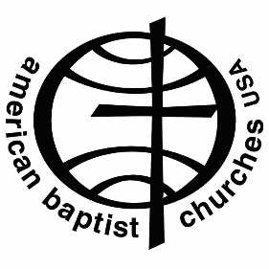**Rev. Dr. Marie Onwubuariri**

**Associate General Secretary**

**for Mission Resource Development**

**American Baptist Churches USA**

Rev. Dr. Marie Onwubuariri joined the American Baptist Churches USA Office of the General Secretary (King of Prussia, PA) in January 2021 as associate general secretary for Mission Resource Development, having oversight of fund development, communications, marketing, and public relations. Within this formal role and in all her American Baptist interconnections, Dr. Onwubuariri seeks to intentionally and collaboratively interweave the rich diversity of American Baptist talents, perspectives, passions, and callings into an experience and narrative of mission and ministry that inspires consideration, contribution, and connection throughout our multicultural denomination.

Onwubuariri served as Regional Executive Minister of ABC Wisconsin from 2014-2020, where she nurtured a regional commitment to living into their cultural diversities by embodying an approach that integrates cultural self-knowing, interpersonal and organizational practices that affirm the value of and ensure equity for all people, and a deep trust in the work of the Triune God.

Onwubuariri has also served as Director of Admissions at the Berkeley School of Theology (BST), Pastor/staff at three America Baptist churches in the San Francisco Bay area, ecumenical cross-cultural competency trainer, volunteer roles throughout the America Baptist denomination and in her local communities, and an executive in the retail industry in New York City and San Francisco.

Her educational training includes a BS in Business Management at Binghamton University (NY), and a Master of Divinity and Doctor of Ministry at BST (Berkeley, CA). She is author of “Reframing Tension for Transformation: Bridge-Crossing | Bridge-Making | Bridge-Being” (Review & Expositor, 118, April 2022), co-editor of “Trouble the Water: A Christian Resource for the Work of Racial Justice” (Nurturing Faith, 2017), and continues to develop her doctoral work focused on holistic intercultural transformational leaders through a character-forming spiritual practice of cultural self-knowing and negotiation.

Whether leading from the front or the fringe, Onwubuariri probes dominant norms and dysfunctional practices, seeking to foster equitable, creative, and impactful spaces for all.

Dr. Onwubuariri is a poet, photographer, and pianist and lives in King of Prussia, PA with her husband, Franklin, children, Anaya and Sol, and golden retriever, Athena.

[marie.onwubuariri@abc-usa.org](mailto:marie.onwubuariri@abc-usa.org)

800-ABC-3USA x2318

484-686-0013 (mobile)