A Call for a Meeting   
of   
the American Baptist Historical Society

In accordance with the laws of Pennsylvania and the bylaws of the American Baptist Historical Society, the American Baptist Historical Society, a Pennsylvania chartered corporation, announces a meeting to be held at 1:00pm EST on 18 November 2020 via video conference. Items of business include official reports and other proper business.

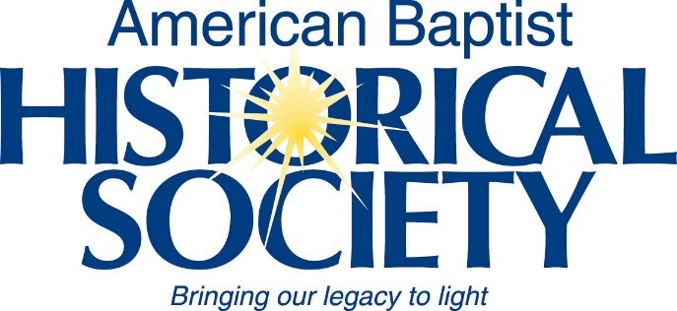Rev. Dr. Jonathan Malone   
President, ABHS Board of Managers