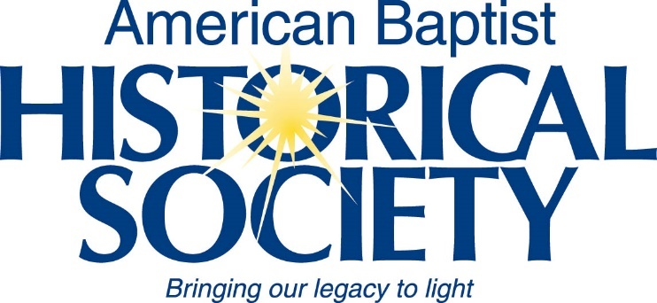American Baptist Historical Society

Annual Corporate Meeting

King of Prussia, PA

The ABHS corporate meeting was held on 9 November 2019 at the Crowne Plaza Hotel, King of Prussia, Pennsylvania.

The meeting was opened by Board of Managers President, Garth Brokaw, who gave a brief devotional. He then introduced Executive Director Priscilla Eppinger.

PEppinger made her oral report to the Board and showed a new [video about ABHS](https://vimeo.com/467783098) and its digital archives project.

GBrokaw gave the floor over to the chair of the ABC/USA Nominating Committee to present nominations for the ABHS Board of Managers. The Nominating Committee report was presented and affirmed by unanimous vote.

With no further business to consider, GBrokaw entertained a motion to adjourn, and the meeting closed.

Respectfully submitted,   
Priscilla Eppinger  
Secretary pro tem