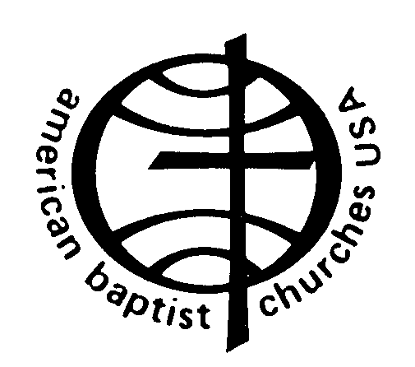

ABC OFFICERS

QUALIFICATIONS AND COMMITMENTS:

1. Commitment to Jesus Christ and the whole mission of the church to evangelize, educate and encourage.
2. Understanding of and respect for the purpose, history, diversity and traditions of the ABCUSA and its ministries.
3. Demonstration of active membership in a contributing ABCUSA church and region and of individual commitment to support its missions financially.
4. Regular participation and involvement in board and committee meetings and willingness to contribute your unique skills and abilities.
5. The ability to listen, negotiate and reconcile which enables us to discern the mind of Christ and build up this community of faith.
6. The ability to lead as well as to serve, to envision the future as well as to plan for it.
7. The desire to study and grow in Christian faith and understanding of the work of Christ in the world today.
8. The ability to communicate to others the goals, programs and ministries of the ABCUSA.
9. Time Commitment: travel and speaking on behalf of the denomination, plus attendance at Board of General Ministries and related committee meetings

     

07/2016
QUALIFandCOMMIT2016

