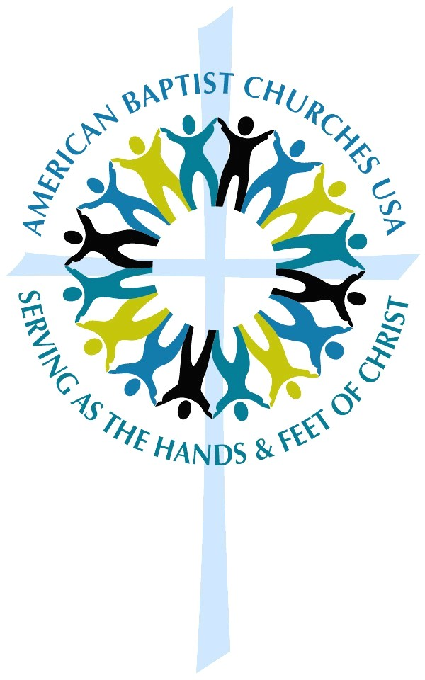

Inspired, Transformed:
Celebrating American
Baptist Churches

Call to Worship
Your works are mighty, O God, and
your name is worthy to be praised.

Through the lives of American Baptist, you have affirmed the gifts of many who went before us to speak truth to power.

God is at work among us. God has given us a strong
heritage of gifted writers.

In the power of Christ, God has gifted our people to be the headlights, leading the way to Christ in ministries of justice, peacemaking, reconciliation and hope.

All Your works are mighty, O God, and your name is
worthy to be praised.

Invocation (in unison)
Blessed God, in humility of heart and spirit, we come to worship you and give thanks for your grace at work among us as American Baptists. You have gifted our churches for over a hundred years with courageous teachers who speak to people all over the world in their own language about the power of Christ to transform their lives. Thank you for the path our feet have trod together, and give us today the vision, the creativity and spiritual insight to make our lives meaningful for you. In the Holy name of Christ we pray. Amen.

Hymn
Holy, Holy, Holy

Scripture:
Isaiah 61:1-12

A Moment of Silence and Reflection

Showing of the film,
“Inspired, Transformed…American Baptist Churches”

Pastoral Prayer/Prayers of the People (in unison)
We come to you this day with a heart filled with thanksgiving. We come to celebrate your gift to us as a people of faith, serving you through the missional ministry of American Baptist Churches USA. Over the years we have accepted your charge to be global ambassadors for Christ, to be a people involved with ministries of reconciliation, bridge-building, peacemaking, healing, prophetic preaching, servant leadership with all cultures and races of people. For these, we give you thanks.

Make us worthy servants as we go forward in our time to build on the legacies of the saints of the past. Empower our youth to take on the heritage we pass on to them. Guide our leaders, both clergy and lay, to take risks for you, confident that you will be with us. Frustrate our plans when they do not serve you and keep us on the path to be worthy disciples for you.

Most of all, empower our youth to take on the heritage we pass on to them. You have given to us this one life, so may we use it well to serve the Christ whom we love. It is in His strong and powerful name we make this prayer. Amen.

This resource is provided to you as a ministry of Mission Resource Development, ABCUSA, and United Mission.
THANK YOU for your generous gifts to United Mission!

