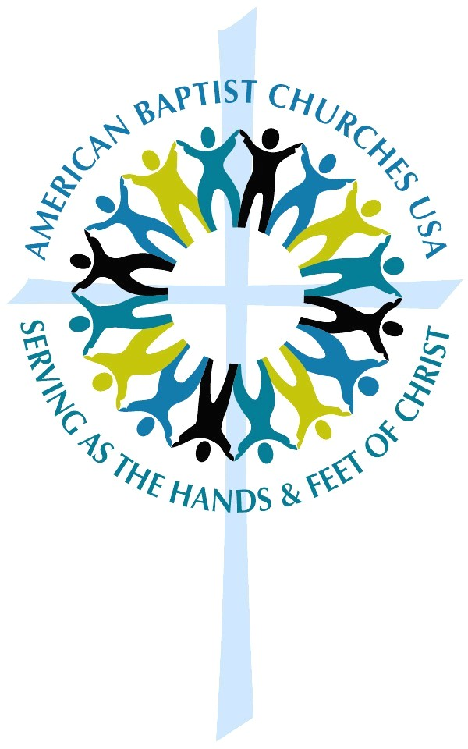

Inspired, Transformed:
Celebrating American
Baptist Churches

Call to Worship
Today is a day of Good News:
God is calling us out for justice and hope,
empowered for action by God’s grace and love.
We give thanks for ministries of peace,
for ways of compassion,
for gifts of service in Christ’s name.
When we gather together in this place,
we are reminded of our identity as God’s people
who are called to transform the world with God’s love.
Today we come with hope
to be ready and courageous partners in ministry.
May God give us strength and inspiration!
May we worship and serve with joy!

Opening Hymn
God of Grace and God of Glory

Invocation

Hymns
Great Is Thy Faithfulness
Shine Jesus Shine
Give Thanks
Lord, I lift your name on High

Showing of Film
Inspired, Transformed…American Baptist Churches

Scripture:
Isaiah 61:1-12

Litany for being Inspired, Transformed

Today may the spirit of the Lord be upon us, anointing us for the ministries we have been called to share.
May God send us to bring good news to the oppressed, to bind up the broken-hearted, to proclaim liberty to the captives, and release to the prisoners, proclaiming the year of the Lord’s favor.
With the powerful witness of generations past, who fought for religious freedom, who marched for justice, who sacrificed much to bring the love of God to the ends of the earth, we realize now it is our turn.
Our turn to give, our turn to decide, our turn to bring hope and light and grace where it is needed most.
We are, every one of us and all of us together, called to do something that will leave this earth better than we found it.
We are the hands and feet of Christ.
God, bless our hands that we can serve you faithfully, touching the world with a compassion that reflects the depths of your love.
God, bless our feet that we can go with courage, out into the world to carry your light, bringing hope to every nation.
God, bless our minds that we can honor and respect each other, seeking understanding and reconciliation to heal and transform every division.
God, bless our spirits and fill us with life that brings life wherever we go.
You have called us and placed your Spirit within us.
Send us now, assured of your sustaining presence,
inspired and transformed,
to boldly bring your Good News of the love of Christ
wherever we may go. Amen.

This resource is provided to you as a ministry of Mission Resource Development, ABCUSA, and United Mission.
THANK YOU for your generous gifts to United Mission!

