ABCUSA MATTHEW 25 GRANT APPLICATION

A generous donor has given a sum of money through American Baptist Churches USA to be used for programs that address “housing, feeding, education and health with regard to the less fortunate.” The donor’s primary concern is to help ameliorate poverty. ABCUSA will distribute grants of up to $5,000 semi-annually as long as the generosity of this donor continues. A panel will select recipients largely based on the degree to which the funds will be used to directly assist persons in poverty. Ministries must be in relationship with American Baptist Churches USA to be eligible to apply.

- General Information:
Organization Name_____________________________________________________________
Affiliation with ABCUSA_________________________________________________________
Address______________________________________________________________________
_____________________________________________________________________________
Phone______________________________ Federal Tax ID#_____________________________
Contact person____________________________email________________________________

- Please submit with your application a copy of:
- Your mission statement
- Your most recent annual report or audited financial statement

- How do you plan to use the requested funds? How will the funds specifically assist individuals battling poverty and its effects? (Please submit on separate sheet. Maximum of one page.)

- Total cost of the project________________________________________________________

- Amount being requested from the ABCUSA Matthew 25 Grant___________________________

- Your other funding source(s)____________________________________________________

I certify that all the information submitted with this application is true and correct, and that we will use any granted funds as described. We will supply a 1-page report on the use of the funds and a photo within six months of receipt of the grant.

(Signed)___________________________________________________Date_______________________

Printed Name/Title_____________________________________________________________________
Please note:
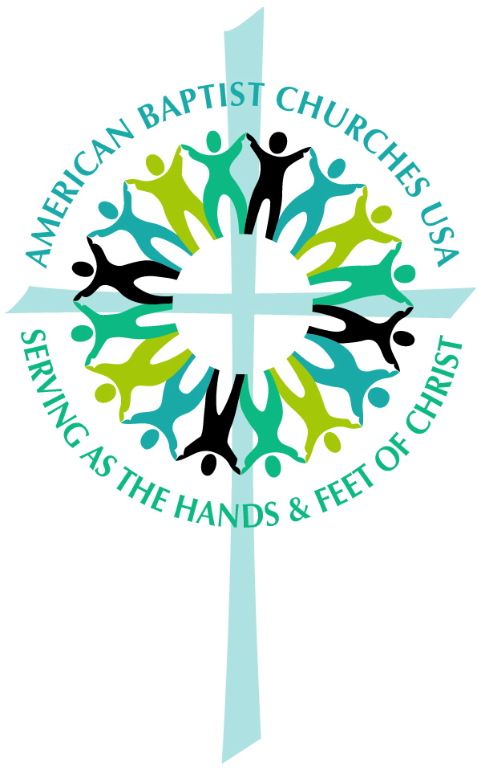
- Incomplete applications will not be considered.
- Recipients agree to share their stories via the ABCUSA website.
- Application deadline is March 1 for grants distributed on April 15; Sept. 1 for grants distributed on Oct. 15
- Completed applications should be sent to:
Mission Resource Development
American Baptist Churches USA
P.O. Box 851
Valley Forge, PA 19482-0851
Or emailed to: Beth.Fogg@abc-usa.org

