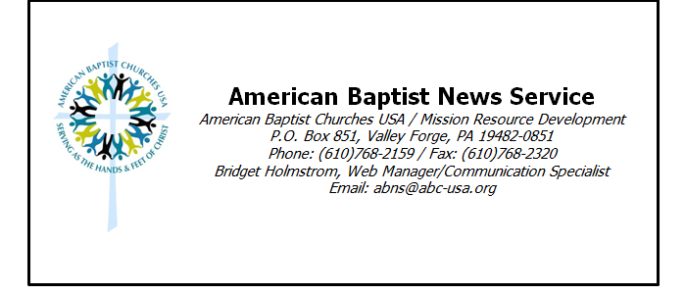

IM Announces the Appointment of Missionaries to Serve in the Philippines and Honduras

VALLEY FORGE, PA (ABNS 12/17/12)—Two missionary couples have been appointed as Associate Missionaries by American Baptist International Ministries (IM). Jonathan and Thelma Nambu were appointed for service in the Philippines, and Dagoberto and Dilia Zelaya were appointed for service in Honduras.
Associate Missionaries and Associate Development Workers are employed by a partnering agency or organization and are appointed to work in association with IM as well as their employing agency. This type of joint appointment along with standard missionary appointment enables IM to support the mobilization of greater numbers of American Baptists into God’s work throughout the world.
Jonathan and Thelma Nambu are appointed in partnership with Samaritana Transformation Ministries, a Christian ministry based in the Philippines that for 20 years has ministered to and among women survivors of trafficking and prostitution. Jonathan and Thelma also provide significant leadership in the global Christian movement to address human trafficking.
More information about the Nambus and their ministry is available on the IM website at http://www.internationalministries.org/teams/566-nambu and the current edition of IM’s print publication, On Location.*
Dagoberto and Dilia Zelaya are appointed in partnership with the First Baptist Church of Marshalltown, Iowa, and are responsible for developing and supervising the Ministries of Faith and New Life in Azacualpa, Honduras.
This ministry provides a home to sixteen children and has launched the Escuela Cristiana Vida Nueva (Christian School of New Life), a bilingual school that includes a classroom for students with special needs. The ministry also provides a meal five days a week to some 50 children in need and a soccer program dedicated to teenagers from the community.
Dagoberto served on IM’s Board of Directors while a member of the American Baptist Churches (ABC) General Board. Having previously endorsed Dagoberto and Dilia for standard appointment, IM and FBC Marshalltown, along with the Zelayas, determined that Associate Ministry appointment better facilitates the goals for the Honduras ministry.

More information about the Zelayas and their ministry is available on the IM website at http://www.internationalministries.org/teams/375-zelaya and the current edition of IM’s print publication, On Location.*

*To request a complementary copy of the print publication, On Location, contact Catherine Nold: catherine.nold@abc-usa.org

American Baptist International Ministries was organized in 1814 as the first Baptist international mission agency in America. It began its pioneer mission work in Burma and today works in Asia, Africa, Europe, the Middle East and the Americas serving more than 1,800 long-term and short-term missionaries. Its central mission is to help people come to faith in Jesus, grow in their relationship with God, and change their worlds through the power of the Spirit. It works with respected partners in over 70 countries in ministries that meet human need.
American Baptist Churches is one of the most diverse Christian denominations today, with over 5,200 local congregations comprised of 1.3 million members, across the United States and Puerto Rico, all engaged in God’s mission around the world.

