RMMO Landing Page for MMBB Website

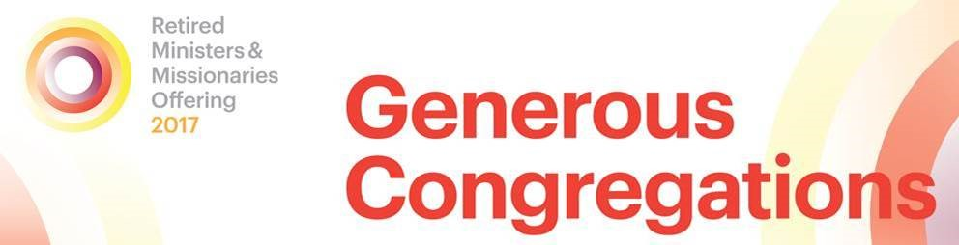

Retired Ministers and Missionaries Offering 2017

The roots of RMMO go back to the mid-1930s, when American Baptist congregations received a Communion Fellowship Offering on the first Sunday of each month to support retired ministers, missionaries, their widowed spouses and elderly clergy within their churches. In 1977, American Baptist Churches USA launched the Retired Ministers and Missionaries Offering (RMMO) to continue this appreciation of God’s service. The offering supports those who have dedicated their lives to God’s service by providing emergency assistance in times of need and a thank you check at the end of each year.

We hope congregations will be inspired by the theme this year, *Generous Congregations.* The verse is taken from Isaiah 32:8, ‘But generous people plan to do what is generous, and they stand firm in their generosity’.” Generosity is central to our faith. As Christians, we are called to serve and care for others, and RMMO aligns with the collective spirit of love that inspires us all to honor the devotion of ministers and their families for their service to the church.

Please join us in honoring God’s committed servants by donating to RMMO.

Thank you for your support.

Now online in English and Spanish

RMMO guide and promotional materials are available in English and Spanish. Please download or print from the PDF’s provided or contact Judson Press at (800) 458-3766 for hard copies of the materials.

In English:

Promotional guide

Bulletin inserts

RMMO posters

In Spanish:

[Guía Promocional](http://www.abc-usa.org/wp-content/uploads/2012/11/RMMO_SpanishGuide.pdf)

[Inserción de Anuncios](http://www.abc-usa.org/wp-content/uploads/2012/11/RMMO_Spanish_Insert.pdf)

[RMMO video](https://vimeo.com/238978257)

Pastors and RMMO recipients comment on RMMO and what it means to them.

(to view or share, click on the link which will take you to the video [‘RMMO 2017 Video’](https://vimeo.com/238978257)

Link: <https://vimeo.com/238978257>

[RMMO 2016 Video – Español](https://vimeo.com/238981922)  
Para poder ver este video, bájelo a su computadora oprimiendo es eslabón titulado [‘RMMO 2017 Español Video’](https://vimeo.com/238981922) que aparece en la parte baja. Esto lo llevara a la página web de Vimeo. Link: <https://vimeo.com/238981922>