INSTRUCTIONS FOR NOMINATION FORMS

ABC OFFICERS (2018-2019)

The procedure for the attached/enclosed forms is as follows:

- To nominate a person for one of the officer positions, complete and return the NOMINATION/RECOMMENDATION FORM (Form #1), indicating by checking one of the officer position boxes at the top of the form to specify for which position the person is being recommended. Please see #7 (below) for submission instructions. Please see that the Candidate receives and reads the “Qualifications and Commitments” sheet. Even though some of the boxes are checked on the forms clicking on the correct box will change the form to the answer you desire.

- The candidate is to complete and return the CANDIDATE PROFILE FORM (Form #2).

- When the PROFILE FORM is received at the Mission Center, a NOMINATION/
RECOMMENDATION FORM (Form #1) for each candidate will be sent to the local church, the region, and the Caucus to be completed.

- The ABCUSA Nominating Committee will review all completed forms.

- The current pool of candidates will be considered in November 2016 at the meeting of the ABCUSA Nominating Committee. Candidate PROFILE FORMS received after October 1, 2016 cannot be considered due to the time needed to secure RECOMMENDATION FORMS from churches, regions, and caucuses. The earlier the PROFILE FORMS are received the better.

- Please note that for the 2018-2019 Biennium the category for President is Layman and the category for Vice President is Laywoman.
- Forms may be downloaded and then completed electronically or forms may be printed and completed. Completed forms may be printed, signed and mailed: ABCUSA, c/o General Secretary, PO Box 851, Valley Forge, PA 19482-0851 OR a digital signature may be added and the form electronically returned to: ABCUSANOMCOM@abc-usa.org.

Questions concerning this process may be addressed to Marilyn Tyson,
1-800/ABC-3USA, Ext. 2292. (1-800-222-3872, x2292).

NOTE: To complete the forms electronically, you will need to have Acrobat Reader DC (link: https://get.adobe.com/reader/)
See following page for instructions on attaching a signature electronically (if desired).

How to Attach a Signature Image to a Nomination Form

- Open the nomination form in the latest version of Adobe Acrobat Reader (currently Acrobat Reader DC).

- In the tools (on the right), select “Fill and Sign.” Then click “Sign” on the toolbar at the top.
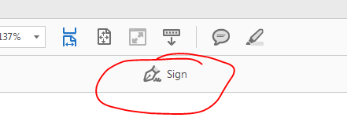
- Choose “Add Signature” and then “Image.”
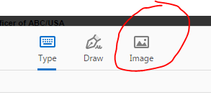

- Find the image of your signature, and select it. When it appears in the signature box, click “Apply.”
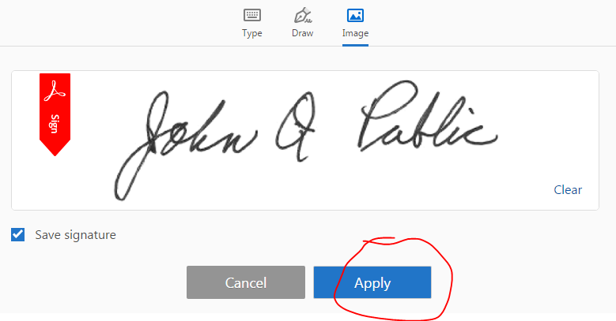
- Scroll down to the signature form field on the nomination form, and click to drop the signature image in that spot. Then save your nomination form.

- You can now email it or print it out and send it through USPS.

InstructionsNomForms

